**Promotions** is a separately purchased module that gives you flexibility and automated functionality for designing and deploying promotions and discounts in your Industries CPQ implementation.

**Advantages of Promotions**

Promotions are separate and distinct from products. This means that product offers and bundles can remain intact. Any promotions you create can apply to products without altering the products.

**Managing Promotions**

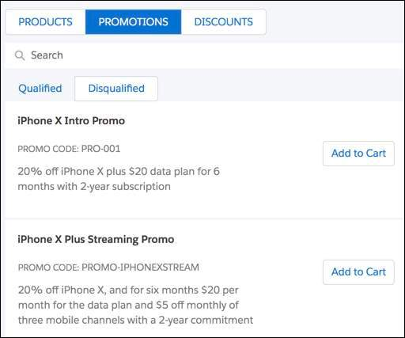

You can manage promotions in the Cart by:

* Searching for promotions in the **PROMOTIONS** list of the Cart
* Deleting promotions placed in the Cart
* Applying a promotion to a product already placed in the Cart

Disqualified promotions can be seen in the Cart. If the customer can meet the requirements for the promotion, it becomes qualified and available.

**Automated Functionality**

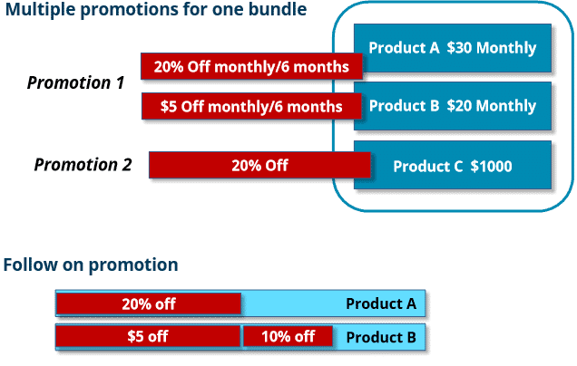

Automated functionality can be based on:

* **Time plan/commitment duration** of the promotion:
  + You can charge a penalty for early termination of a subscription using penalty context rules.
  + You can create a follow-on promotion that automatically begins when a previous promotion ends.
* **Service continuation:** Subscriptions can be automatically cancelled or continue after a promotion ends based on settings within the promotion.
* What the promotion applies to:  promotions can apply to **assets**as well as to items in the Cart.

# Promotion Basics and Building Stages

You can create promotions on existing products and product bundles.

Promotions have settings for:

* The duration of the subscription and the way the subscription begins and ends
* Different ways to discount the products in the promotion and how long each discount lasts
* Whether the promotion:
  + Should or should not appear in the list of promotions to manually add to the Cart
  + Is automatically applied to a customer's account
  + Begins immediately after a previous promotion
  + Can be applied to a product the customer has already purchased

**Promotion Basics**

**What is the difference between a product and a promotion?**

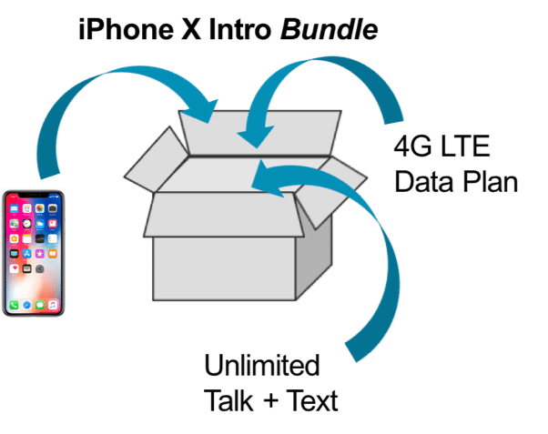

A product:

* Can be used on an ongoing basis and typically does not expire soon
* Contains products or quantities of each product that are not necessarily limited
* Can contain multiple bundles

Products can be bundled together with the pricing of child products totalled (or “rolled up”) and added to the price of the parent product.

Typically, promotions are individual products or product bundles you create for a limited:

* Time
* Customer group
* Subset of products

You can use promotions to apply to products you have already created.

**When do you use a product and when do you use a promotion?**

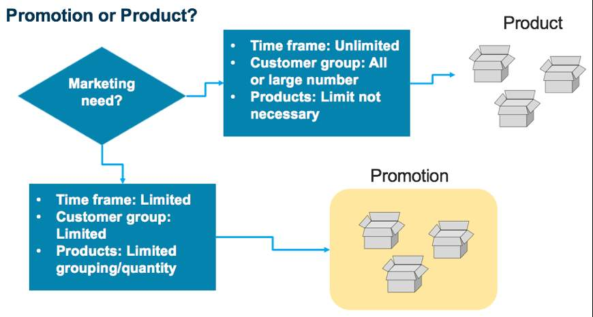

**Product Time Plans and Cardinality**

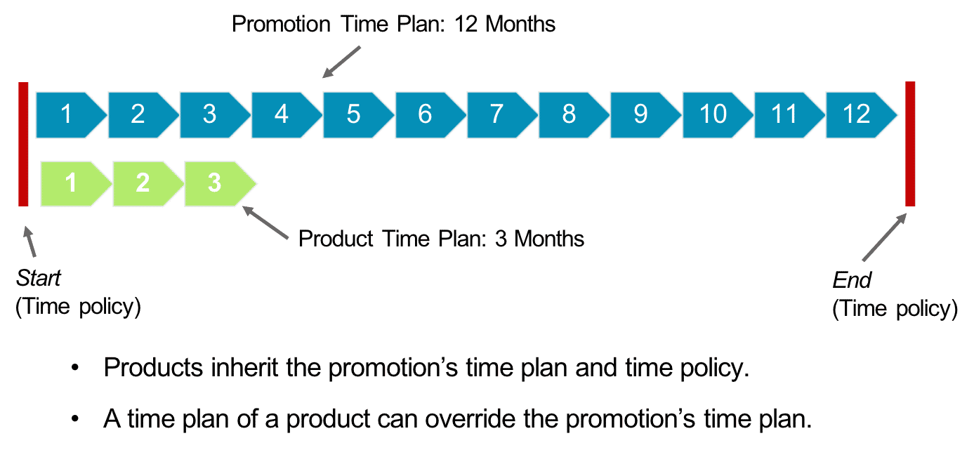

**Discount Duration**

When a product's charge recurs on a regular basis, such as every month, you can decide how long a promotional discount on the charge will last. It can last the entire length of the promotion, or it can end before the promotion commitment duration ends.

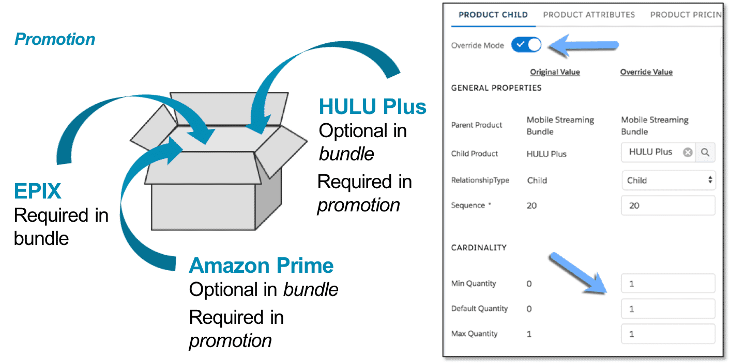

**Changing Min/Max/Default Amounts of a Child Product**

You can override the original cardinality of any product in a promotion. In this example, two products that are normally optional in the bundle are required in the promotion.

# Automated Functionality for Promotions

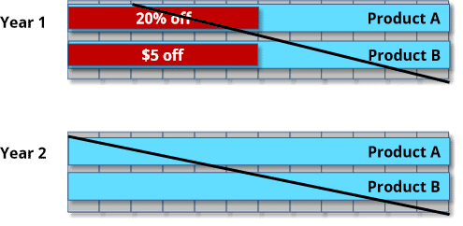

**Penalty for Cancelled Promotion**

You can use a context rule to issue a penalty against an account that has cancelled promotional discounts.

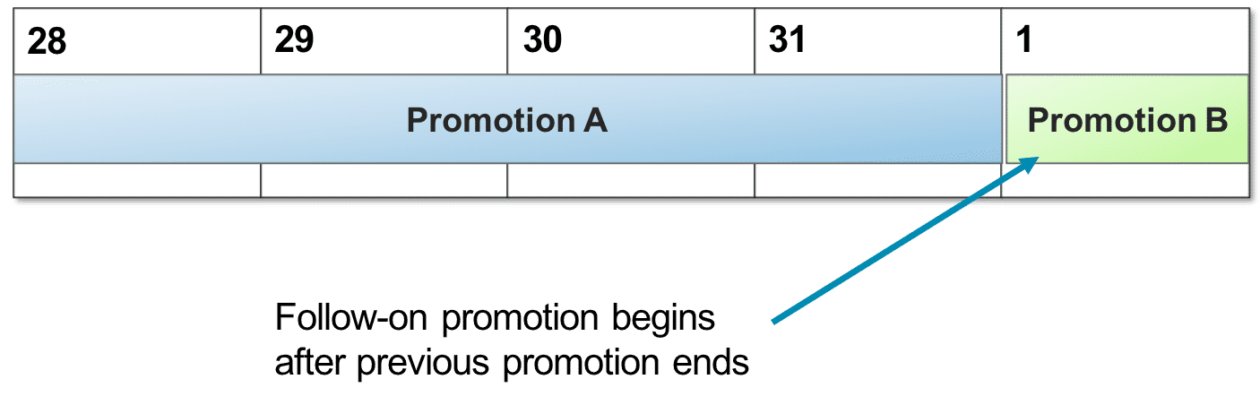

**One Promotion Begins After a Previous One Ends**

You can create a follow-on promotion that does not appear in the Cart. Instead, you can set it to begin as soon as a previous promotion ends.

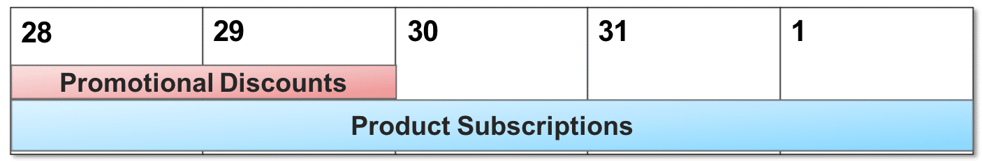

**Manually Opt Out to End Subscription**

If the promotion is set to **Manually Opt Out**,  the customer must contact you to request the subscription to end.  If they do not, the promotional discounts to the promotion end, but the subscription continues

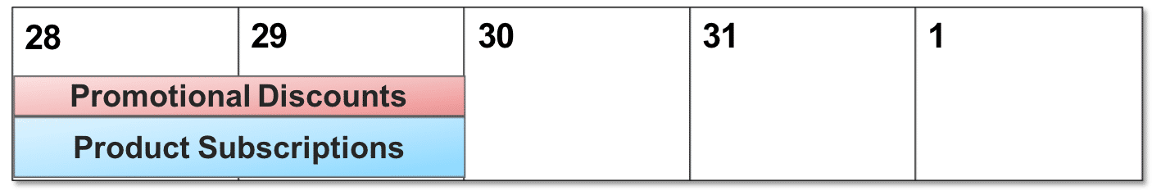

**Manually Opt In To Continue Subscription**

If the promotion is set to **Manually Opt In**, the customer must contact you to request the subscription to continue. If they do not, the promotional discounts to the promotion and the subscription ends.

# Adjusting the Prices of Products in a Promotion

You can change the price of any product in a promotion by adjusting the price by a percentage or an amount. In addition to adjusting the price, you can set how long the adjusted price will last by assigning a time plan. Say, 20% off for 3 months or $5 off monthly for 6 months, for example.

When adjusting the price of a product in a promotion it is not necessary to run the Product Hierarchy Maintenance, Clear Managed Platform Cache or the Refresh Platform Cache jobs as explained in the EPC module.

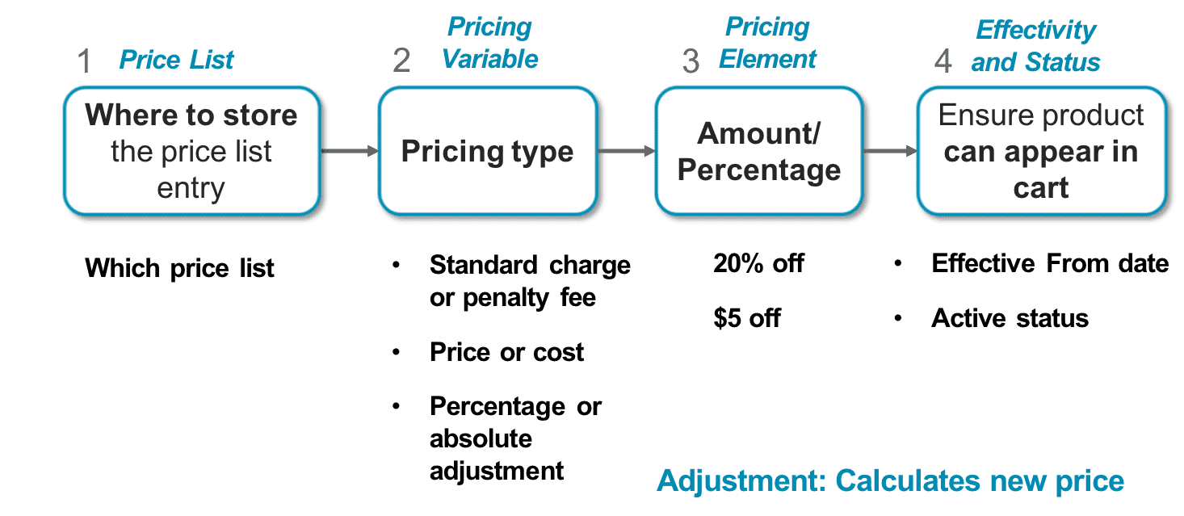

# Overriding the Prices of Products in a Promotion

You have the option of overriding the price of a product in a promotion rather than adjusting it by a percentage or amount. So, instead of adjusting the price to 20% off $34.99 for 3 months you override the $34.99 price to $24.99. And, you can assign a time plan to the override as well. Therefore, in this example the price of the product in the promotion is $24.99 for 3 months.

When you override the price of a product you do not need to run the Product Hierarchy Maintenance, Clear Managed Platform Cache or the Refresh Platform Cache jobs.

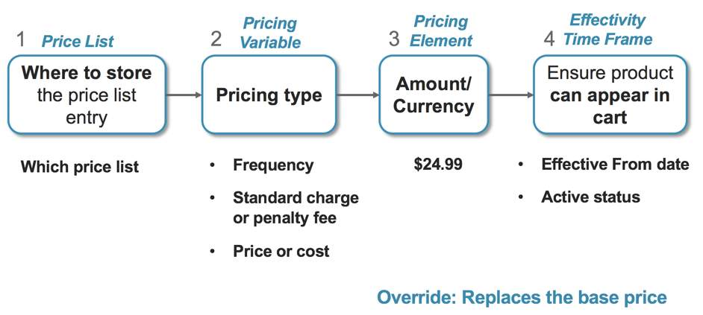

# Refining Promotions

There are two setting options for the **Update Scope** field when building out a promotion for a product bundle. The Update Scope field controls how the promotion is applied to the bundle in the Cart.

1. **Update Item Only:** the parent product is the only product that is updated for the promotion. No promotional changes are made to the child products in the Cart.2
2. **Update Item and Child Items:** the parent product and its child products are updated for the promotion in the Cart.

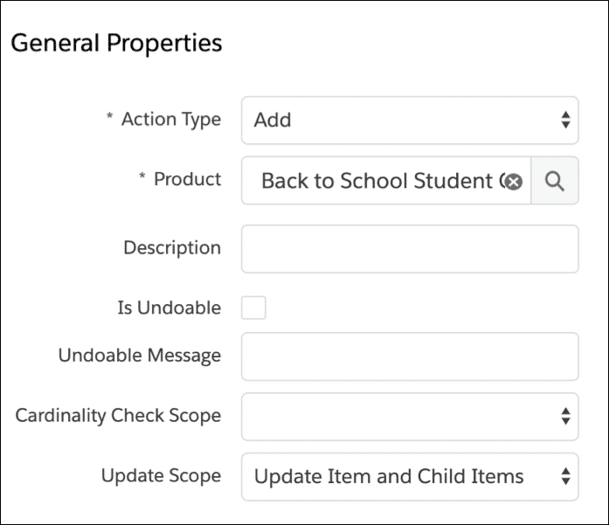

# Deleting Promotions

There are two settings in which to delete promotions in the Cart.

* 1

**Deep Delete:**a deep delete removes the promotion and its changes along with the products pertaining to the promotion. This is the default setting for DeleteServices.

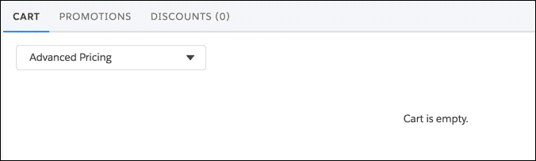

* 2

**Shallow Delete:** when you delete the promotion it only deletes the promotion and its changes (discounts and cardinality). The products that the promotion applies to remain in the Cart. To change the delete to a shallow delete, edit the DeleteServices setting.

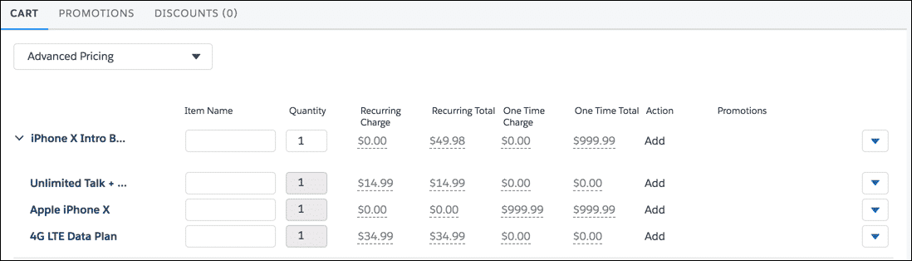

**Changing the DeleteServices Setting**

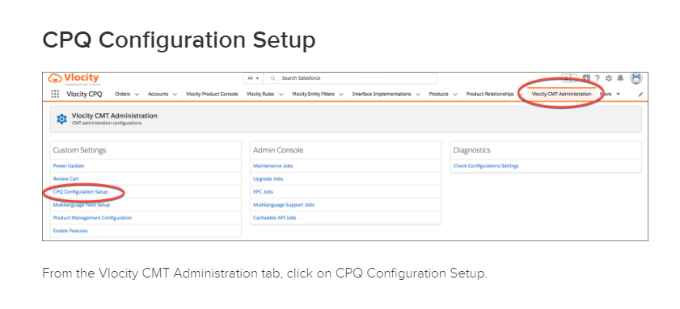

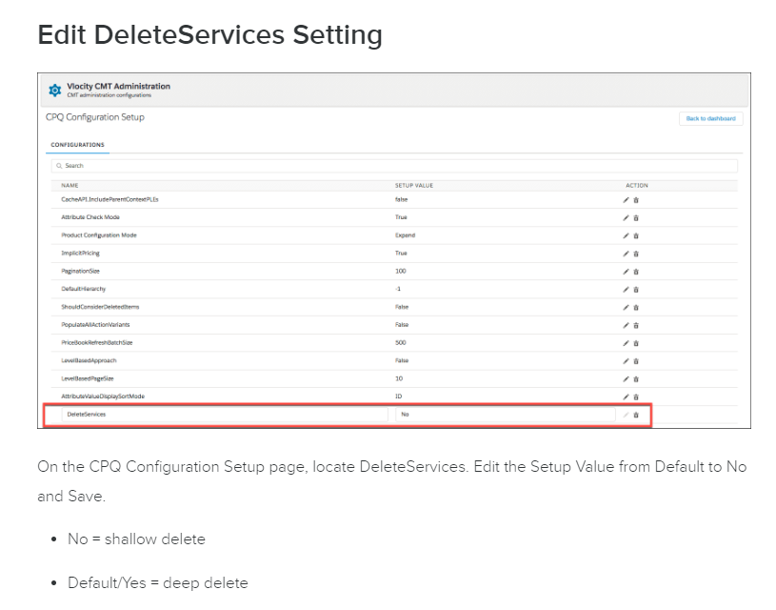

# Creating Multiple Promotions for a Bundle

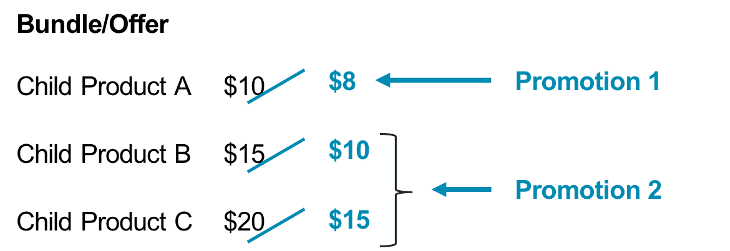

You can create more than one promotion to apply to a single bundle of products.

For example, Promotion 1 discounts child product A. Promotion 2 discounts child products B and C

When you have applied more than one promotion to a bundle in the Cart, you must have shallow delete enabled. Then you can delete each promotion individually.

If deep delete is enabled, you cannot delete multiple promotions applied to one bundle of products.

# What are Contextual Discounts?

The Promotions module includes contextual discounts. Contextual discounts provide yet another way to reduce the price of a product, but also allow for a reduction in price to a sales catalog (collection of products), or all products in the Cart, and can be applied towards current or future purchases.

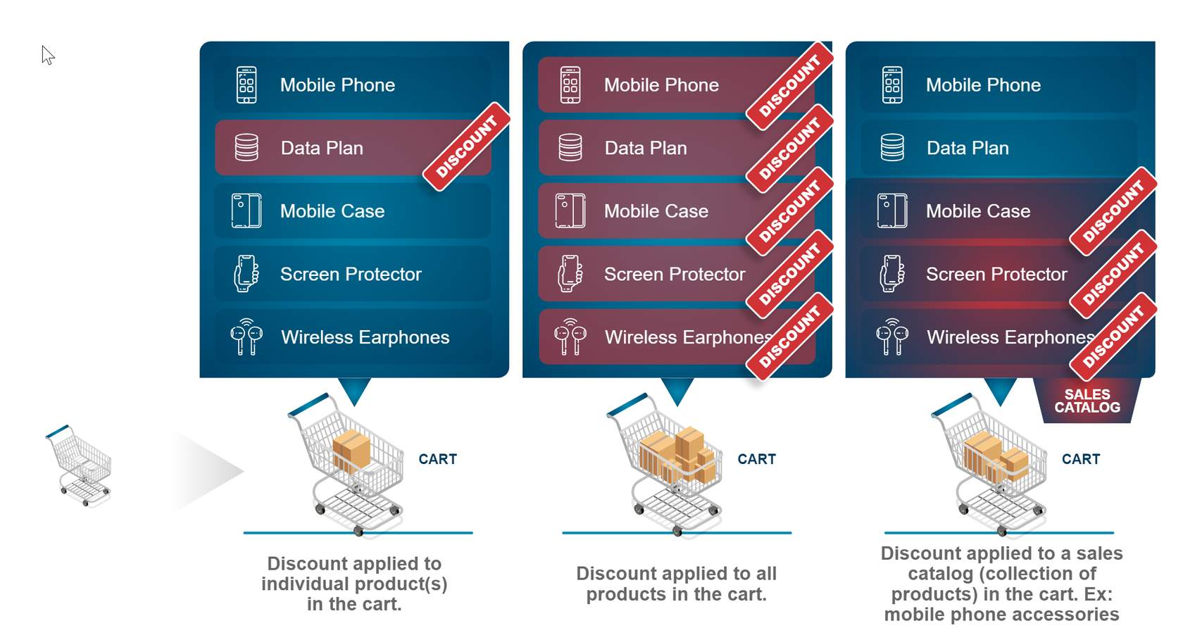

Contextual discounts are contractual in nature, meaning they typically are associated with an account or contract, and these discounts persist during the term of the contract. In contrast, discounts from an applied promotion or manual adjustment are considered transactional and are applicable based on the conditions that occur for each individual order.

**Capabilities and Benefits**

|  |  |
| --- | --- |
| **CAPABILITIES** | **BENEFITS** |
| * Contextual Discounts can be defined to be automatically applied against a customer account, contract (frame agreement) or a specific order. * Sales reps or customer service reps (CSRs) are given the ability to negotiate, approve and apply discounts. * CSRs can apply discounts against a specific product, group of products or against all line items. | * By discounting the entire Cart it can incentivize the sales order flow. * Contextual Discounts support loyalty and retention (L&R) scenarios to attract and maintain customer approval ratings. * Contextual Discount pricing components can be injected to support frame agreements. |

| **Contextual Discounts** | **Promotions** | **Description** |
| --- | --- | --- |
| Can be applied automatically to future orders | NA | You can define and apply discounts to future orders linked to specified accounts and contacts. You cannot do so with promotions. |
| Negotiable | NA | Discounts are negotiable (editable) in the Cart, such as amount or percent of discount offered, number of months the discount is active on an account or contract, adjusting end dates, sales catalog of products it applies to, etc. You cannot negotiate (edit) a promotion in the Cart. |
| Supports a sales catalog | NA | Discounts can be applied to a product or a group of products (sales catalog), such as all phone accessories. Promotions can only be applied to products. |
| Supports as-hoc creation | NA | Discounts can be created on an ad-hoc basis in the Cart. Promotions are defined in the Product Console. |
| NA | Penalty fees and continuation options | Penalty fees do not apply to discounts. In addition, customers are not concerned with manually opting in or out of discounts. Discounts with an end date or duration expire automatically and discounts without an end date or duration never expire. |

# Contextual Discount Types

The three types of discount we support are as follows:

1. Order-Based
2. Account-Based
3. Contract-Based

**Order-Based Discounts**

An order-based discount is defined as a one-time discount that is applied at the time of purchase. You can identify, create and apply an order-based discount against a specific product, a collection of products (sales catalogs or categories) or all items in the Cart. The reduction in price can be specified using a percentage (10% off) or an absolute value ($10 off). This is categorized as a contractual type discount because it can be applied against a sales catalog or all items in the Cart, whereas transactional discounts (promotions) cannot.

This type of discount is useful during a conversation between a CSR and a customer during an active sales order to incentivize the customer's behavior to purchase additional products and/or services. Could a CSR manually adjust the price of each product in the cart to incentivize the customer? Absolutely, but with order-based discounts, the CSR could have several pre-built options to choose from to incentivize the customer and add it to the order.

For example, if a customer is considering upgrading their iPhone today, the CSR could offer a pre-built discount of 20% off all iPhone accessories in an attempt to close the sale.

Order-based discounts differ from account-based and contract-based in that they can only be applied once to the product or sales catalog for that instance of the order.

**Account-Based Discounts**

An account-based discount does everything an order-based discount does. However, these discounts can be saved against an account for future discounting. Account-based discounts allow you to apply a reduction in price to products and/or services in the future. This means the discount can be applied towards any future purchases made as part of the account until the validity of the discount ends, and it applies to all orders or individual orders in an account.

This type of discount is most relevant during a conversation between a CSR and a customer, especially to retain the business of a loyal customer as part of a L&R program.

For example, ABC Company negotiates a 15% discount on all internet services. The negotiated discount is stored in ABC Company’s account. Any future orders for ABC Company will receive a 15% discount on internet services.

**Contract-Based Discounts**

A contract-based discount does everything an account-based discount does; however, this discount applies a negotiated discount specified in a contract to a product or sales catalog.

During contract negotiations, this type of discount is useful and may become part of a frame agreement. You can use frame agreements to set up product, category and account level discounts and use them to drive pricing for future sales. By using frame agreements, you can avoid the need for individual contracts for each new deal because terms are pre-negotiated by the frame agreement. You must create a frame agreement and activate the contract for the contract-based discount to be activated.

For example, an account executive negotiates and establishes a 5% discount on all accessories for employees of company XYZ who have purchased iPhone products. The 5% discount is stored under company XYZ. When any new employee joins company XYZ, the 5% discount is applied when they add any iPhone accessories to the Cart.

# Pick the Right Pricing Adjustment for the Job

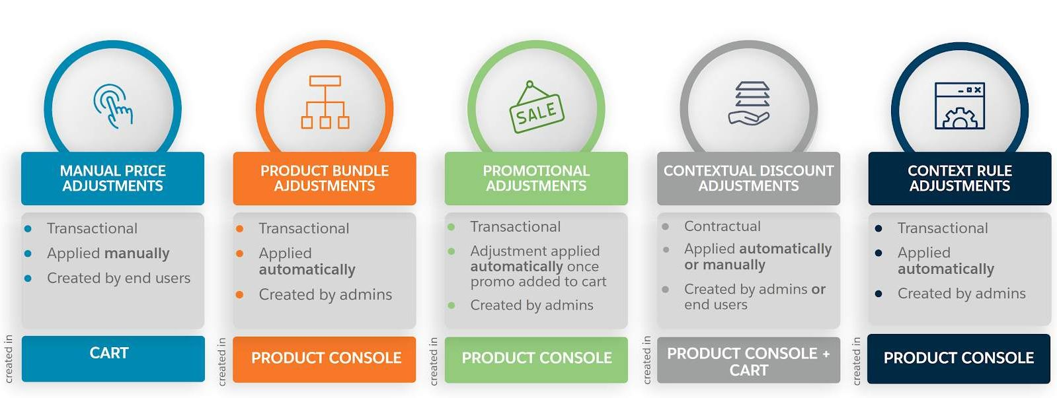

**Manually**

You can manually change any price that displays in the recurring or one-time column in the Cart. This includes any price that has already been adjusted as a result of bundling (child products), a promotion, discount, or context rule and would be considered transactional in nature. A CSR has the ability to edit the price by a percentage (10%), an absolute amount ($10), or override the price entirely. Adjusting a recurring charge also provides the ability to limit the duration of the adjusted price by a time plan and determine how and when the adjusted price starts and ends with a time policy.

**Create Bundles**

A product bundle contains one or more child products and the pricing of those child products always roll up to the total price of the bundle. To incentivize a customer into buying a bundled product instead of each product individually you can adjust/override the price of all or specific child products. Adjusting the price of child products is performed by an Industries CPQ product administrator in the Product Console within the Product Structure facet of the bundle. When the bundle is added to the Cart by a CSR, the child products will display the discounted price. This is considered transactional because the discounted bundle is not specific to an account or contract.

**Apply a Promotion**

Promotions are usually product bundles with a price adjustment on one or more products in the bundle. Although, promotions can consist of individual products as well. However, a promotion is designed to limit the time the adjusted price is offered to a customer, and in conjunction with context rules can be limited to a certain customer group and/or a limited subset of products. You adjust the price of products assigned to the promotion within the Product Adjustments facet and is a task performed by an Industries CPQ pricing administrator in the Product Console. Once an order is created a CSR applies one or more promotions to adjust the price of products in the Cart. This is considered transactional because an applied promotion is typically not captured on future orders.

**Add a Contextual Discount**

Contextual Discounts (discounts) are similar to promotions in that they can be associated with a single product or bundled products, but discounts go one step further than promotions and allow for discounting of all products in the Cart. Discounts also can be negotiated and applied to current and future orders, support product sales catalogs and can be created on an ad-hoc basis using the custom discount feature, unlike promotions. In addition, discounts can be applied to orders to incentivize customers, accounts as a loyalty and retention program or a contract as part of a frame agreement. These types of discounts are considered contractual because they apply to a specific customer or contract. Discounts are created by Industries CPQ product administrators in the Product Console but added to the Cart by a CSR. A CSR has the ability to create custom discounts if none of the available discounts (order, account, or contract) match the needed criteria.

**Create a Context Rule**

Rules allow you to change the pricing behavior in the Cart in accordance with your business objective. Context rules can be used to determine if products, promotions or discounts qualify and display in the Cart. But they also can be used to determine eligibility of price lists and price list entries. When a context rule is used with a child price list or price list entry, it is used to determine what price displays on the product in the Cart. When a CSR creates an order a triggering event may occur that will kick off the rules engine that ultimately displays the adjusted price of products in the Cart. Context rules are created by Industries CPQ product administrators in the Product Console.